**SMART IRRIGATION AND MOINTORING SYSTEM USING IOT**

1. **INTRODUCTION**

Long before the term “Internet of Things” (IoT) became popular, early steps toward smart automation had already begun. In the pre-Internet era, basic home automation systems, such as those based on the X10 protocol, were developed to control electronic devices remotely using power line communication. These initial systems laid the groundwork for what would later evolve into connected smart environments. In the early 1990s, researchers and technologists began imagining more advanced concepts involving intelligent, interactive environments. One such vision was the "Digital Desk," which introduced the idea of combining physical objects with digital information. These concepts gave rise to the notion of “augmented objects,” where everyday items could become part of an interactive network, merging the digital and physical worlds. This marked a shift toward creating seamless interfaces that respond to human actions in intuitive ways.

Simultaneously, computer scientist Mark Weiser proposed the concept of "ubiquitous computing," where computing technology becomes embedded in the background of daily life. His idea of "embodied virtuality" predicted a future where computing would be woven into the very fabric of the environment, rather than being confined to standalone devices. These early ideas are now becoming a reality as IoT technologies continue to evolve. By the late 1990s, the Auto-ID Center played a crucial role in advancing the future of connected objects. It introduced the use of RFID (Radio Frequency Identification) tags, which enabled individual items to be uniquely identified and tracked. Each RFID tag contained a simple microchip with a unique identifier, and while it didn't store detailed information itself, it could communicate wirelessly with nearby readers.

Over time, these pioneering technologies and ideas merged to form what we now recognize as the Internet of Things—an ecosystem of interconnected devices that collect, share, and act on data to improve efficiency, convenience, and decision-making across countless domains. It begins with the **Pre-Internet** phase, characterized by human-to-human communication through fixed/mobile telephony and SMS. The next phase**, Internet of Content,** introduced the World Wide Web, enabling e-mail, information access, and entertainment. This was followed by the **Internet of Services** with Web 2.0 technologies that facilitated e-productivity and e-commerce. Then came the **Internet of People,** marked by social media platforms like Skype, Facebook, and YouTube, enhancing connectivity between individuals. Finally, the **Internet of Things** emerged, focusing on machine-to-machine communication involving tracking, monitoring, automation, and smart environments. Internet of things in each faces are refers in Fig.1.1

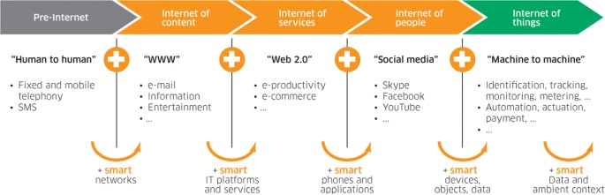

## Fig.1.1 Internet of things in each faces

## 1.1 ROLES OF EMBEDDED SYSTEMS AND IOT

Embedded systems serve as the core of IoT devices. These systems consist of a microcontroller or microprocessor, memory, input/output interfaces, and software designed to perform specific tasks. In an IoT setup, embedded systems collect data from sensors and process it locally or transmit it to a central server or cloud. They ensure real-time interaction between the physical world and the digital network, making them the backbone of IoT infrastructure. Embedded systems in IoT devices are typically connected to various sensors that monitor parameters such as temperature, humidity, motion, light, and more. These systems are responsible for reading sensor data, converting it into digital form, and applying basic processing or filtering. This capability enables smart applications like environmental monitoring, health tracking, industrial automation, and smart homes.

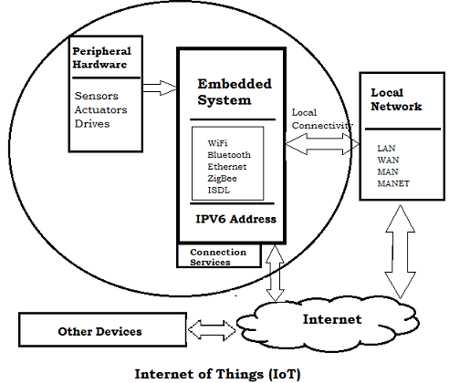

**Fig.1.2 Embedded system and IoT**

The Fig.1.2 provides a high-level overview of the **Internet of Things (IoT)** architecture and emphasizes the central role of **embedded systems** in enabling IoT functionality. At the core of the setup is the **embedded system,** which interfaces directly with **peripheral hardware** such as sensors, actuators, and drives. These components collect data from the physical environment and relay it to the embedded system for processing. The embedded system then interprets the data and can issue commands back to the hardware for action, enabling automation and control.

This figure also shows that embedded systems are equipped with multiple **communication interfaces,** including WiFi, Bluetooth, Ethernet, ZigBee, and ISDL. These interfaces allow the embedded system to connect either **locally** to a **network** (like LAN, WAN, MAN, or MANET) or directly to the **internet** using an **IPv6 address.** This connectivity facilitates seamless communication between the embedded system and other devices or cloud-based services, enabling remote monitoring, data analytics, and real-time control. Embedded systems are indispensable in the evolution of IoT. Their ability to seamlessly integrate hardware and software components enables efficient data handling and device control. As technology continues to advance, the demand for sophisticated, secure, and efficient embedded systems will grow. By embracing innovation and addressing existing challenges, developers can unlock the full potential of embedded systems and drive the future of connected technology.

**1.2** **IMPLEMENTATION AREAS OF EMBEDDED SYSTEM AND IOT**

The Internet of Things (IoT) has found wide-ranging applications across multiple sectors, significantly transforming the way systems operate and interact. In **smart homes**, IoT enables automation of lighting, security, and appliances, enhancing comfort and energy efficiency. In the **healthcare sector**, wearable devices and remote monitoring systems help track patient health in real time, improving diagnostics and emergency response. **Industrial IoT (IIoT)** allows for predictive maintenance, real-time monitoring, and process automation in manufacturing environments, boosting productivity and reducing downtime.

In **agriculture**, IoT is used for smart irrigation, soil health monitoring, and weather forecasting, leading to more efficient farming practices. **Transportation** benefits from vehicle tracking, fleet management, and intelligent traffic control systems. **Smart cities** leverage IoT for efficient waste management, environmental monitoring, and intelligent street lighting, while the **retail sector** uses IoT for inventory tracking and personalized customer experiences.

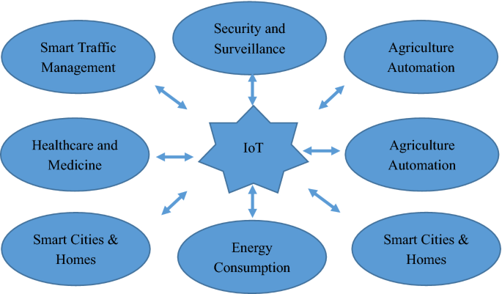

**Fig.1.3 Implementation areas of embedded system and IoT**

**1.3 IMPLEMENTATION OF IOT IN AGRICULTURE**

Smart Agriculture, also called precision agriculture or agrotechnology, is all about using advanced technologies & data-driven approaches for optimizing agricultural practices and improving overall efficiency. Smart farming leverages the power of automation, connectivity, and real-time monitoring to enhance decision-making processes & maximizing agricultural output. IoT provides a network of interconnected devices and sensors for the industry that collects and share data. They can be embedded in soil, crops, machinery, and livestock to monitor temperature, humidity, soil moisture, nutrient levels, and animal behavior.

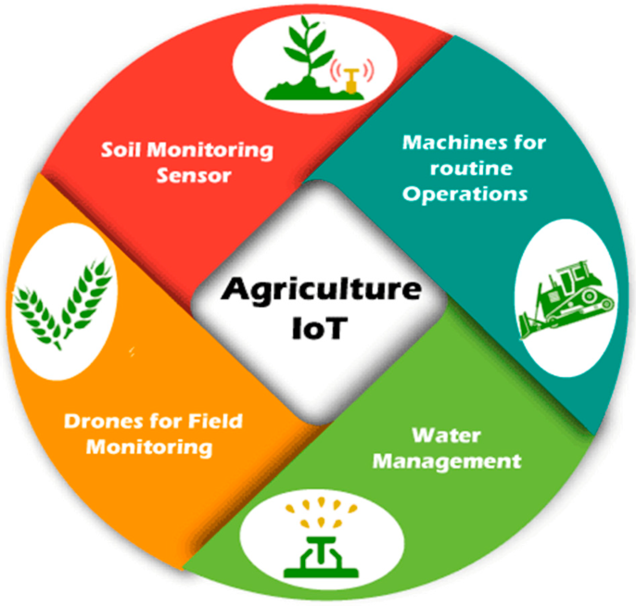 Further, this gathered data is then analyzed & utilized for making informed decisions about irrigation, fertilization, disease prevention, and overall farm management. For instance, farmers can now access real-time data from their smartphones or tablet and monitor soil conditions and crop health. Precise insights enable efficient decision-making to maximize fertilizer usage and optimize farm vehicle routes.

**Fig.1.4 Use Cases of Iot in Agriculture**

**1.4 EFFICIENT SOIL MOINTORING USING IOT**

Efficient soil monitoring is a critical component of modern precision agriculture, helping farmers optimize resource usage and enhance crop productivity. Traditional soil analysis methods are often time-consuming and labor-intensive. With the advent of the Internet of Things (IoT), it is now possible to automate and streamline the process of soil monitoring using smart sensors and connected systems. These IoT-based solutions provide real-time data, improving decision-making in farming practices. An IoT-based soil monitoring system typically consists of various sensors such as moisture, temperature, pH, and nutrient level sensors, which are embedded in the soil. These sensors are connected to a microcontroller (like an Arduino or ESP32), which collects the data and transmits it to a cloud platform or local server via Wi-Fi, Bluetooth, or LoRa. The system may also include solar panels for energy efficiency and mobile apps or web interfaces for data visualization and control.

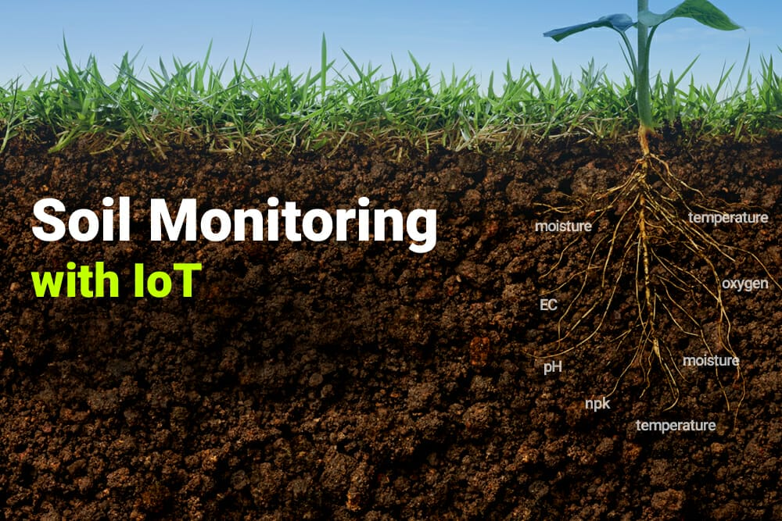

## Fig.1.4 Soil Monitoring Using Iot

While IoT-based soil monitoring systems offer numerous benefits, there are also challenges such as sensor accuracy, maintenance, and connectivity issues in remote areas. However, with advancements in low-power devices, edge computing, and AI integration, the future of IoT in agriculture looks promising. As these technologies become more accessible and affordable, efficient soil monitoring will become a standard practice, revolutionizing farming on a global scale.

**1.5 WORKING OF IOT BASED CROP MONITORING SYSTEM**

The smart farming system starts with the initialization of all essential components. These include various sensors like soil moisture and light sensors, relays to control devices like the water pump and lights, and the IoT module for communication. Once the system is powered on, it prepares itself to monitor and respond to the conditions in the agricultural field. The first step in the process is checking the soil moisture level. The system reads data from the soil moisture sensor to determine whether the soil is dry or adequately moist. If the moisture level is found to be low, it means the crops need watering. In this case, the system automatically triggers the water pump to start irrigation and updates this action to the IoT platform, 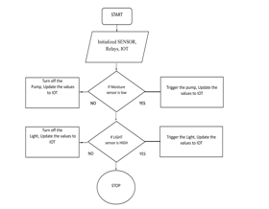where farmers can view the status remotely.

**Fig.1.5. working of crop monitoring system**

On the other hand, if the soil moisture is sufficient, the system ensures that the pump is turned off to avoid over-irrigation. This helps in conserving water and energy. The system also updates this status to the IoT platform so that farmers are aware that irrigation is not needed at the moment.

Next, the system checks the light intensity using a light sensor. If the light sensor detects that the light level is high, which may be an indication of night-time or cloudy weather, the system turns on artificial lights to support plant growth. This action is also updated to the IoT network for real-time monitoring. Finally, if the light intensity is not high, the system ensures the light remains off, again updating this to the IoT dashboard. After completing these checks and actions, the system ends the current cycle. This automated model helps farmers monitor and manage their fields efficiently with minimal human intervention, leading to better crop health, reduced resource usage, and increased productivity.

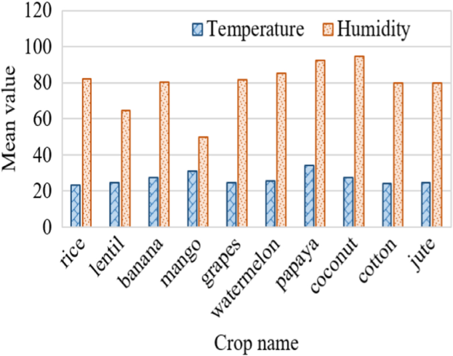 Fig.5.1 graphical representation

* 1. **MOTIVATION OF THE PROJECT**

In recent years, agriculture has faced several challenges due to unpredictable climate changes, water scarcity, and a lack of timely information on crop health. Traditional farming methods involve manual monitoring of soil and crop conditions, which is time-consuming and inefficient. Farmers often rely on guesswork or outdated practices to decide when to irrigate, leading to either over-watering or under-watering. This not only wastes water but also affects crop yield. The need for a more efficient, accurate, and automated solution led to the idea of integrating IoT into agriculture.

Water is one of the most critical resources in farming, yet it is often wasted due to inefficient irrigation methods. In regions facing water shortages, smart water management is essential. A smart irrigation system can help farmers optimize water usage by supplying water only when the soil actually needs it. This is possible by using real-time data from soil moisture sensors. The goal is to conserve water, reduce operational costs, and ensure crops receive the right amount of water at the right time. In addition to soil moisture, other environmental factors like temperature, humidity, and light play a vital role in crop growth. IoT-based monitoring systems can continuously track these parameters and provide data to farmers via mobile or web platforms. This constant monitoring allows farmers to take preventive actions against diseases, pests, or unsuitable weather conditions, thus reducing crop loss and improving productivity.

One of the major motivations is to reduce the dependency on manual labor, which is declining due to urban migration. Many farmers are either aging or moving to cities for better opportunities, leaving a gap in agricultural labor. Smart systems reduce the need for constant human presence in the field, making it easier for farmers to manage their land with minimal intervention. Finally, smart irrigation and monitoring systems contribute to sustainablefarming. By using technology to increase efficiency, reduce waste, and improve yields, these systems support food security and environmental conservation. The use of IoT in agriculture reflects the growing trend of digital transformation and smart technologies that aim to solve real-world problems with innovation and data-driven solutions.

**1.7 SCOPE OF THE PROJECT**

The scope of the Smart Irrigation and Monitoring System using IoT includes the development of an automated system that monitors key environmental parameters like soil moisture, temperature, humidity, and light intensity using sensors. Based on real-time data, the system can automatically control irrigation by activating or deactivating a water pump. All data is sent to an IoT platform, allowing farmers to monitor field conditions remotely via smartphones or web interfaces. This enhances precision farming, improves crop health, and reduces water and energy wastage.

This project has a wide scope in both small-scale and large-scale agriculture. It can be implemented in farms, gardens, greenhouses, and nurseries. It also supports scalability and future expansion by adding more sensors or integrating AI for predictive analysis. The system not only helps in better resource management but also empowers farmers with real-time insights, reducing manual labor and promoting sustainable farming practices through technology. It can also generate real-time alerts for abnormal conditions and can be integrated with weather forecasting for intelligent irrigation scheduling.

**1.8 OBJECTIVE OF THE PROJECT**

* To automate the irrigation process based on real-time soil moisture levels, reducing manual labor and ensuring efficient water usage.
* To monitor environmental parameters such as temperature, humidity, and light intensity continuously for better crop management.
* To provide remote access and control of the irrigation system through IoT platforms, enabling farmers to manage their fields from anywhere.
* To optimize the use of natural resources like water and electricity, leading to cost savings and sustainable farming practices.
* To increase crop productivity and health by maintaining ideal growing conditions and minimizing human errors in irrigation decisions.

**1.9 ORGANISATION OF THE REPORT**

The Organization of the report as follows,

**Section-1:** Overview of smart irrigation and monitoring systems, emphasizing their importance in modern agriculture. Discussion on the role of IoT in precision farming and the motivation behind automating irrigation processes.

**Section 2:** Review of relevant scholarly articles and previous research focused on smart irrigation, sensor-based monitoring, and IoT applications in agriculture. Comparative analysis of existing smart farming systems, highlighting their strengths and limitations. Identification of challenges in current systems and exploration of areas where improvements can be made for better efficiency and usability.

**Section 3** Presentation of the proposed smart irrigation and monitoring system designed in this project. Detailed specifications of the hardware components, including microcontrollers (e.g., ESP8266/Arduino), sensors, relays, and IoT modules. Explanation of the system architecture, working principle, and the design process adopted to achieve reliable and automated field monitoring.

**Section 4:** Examination of the experimental results obtained through testing the proposed system in simulated or real agricultural conditions. Analysis of system performance in terms of sensor accuracy, water conservation, and responsiveness. Discussion on any observed discrepancies, technical challenges, or unexpected behaviors during system testing and their impact on the project objectives..

**Section 5:** Summary of the key outcomes of the project and their relevance to advancing smart agriculture. Discussion of the system’s contribution toward sustainable and efficient farming practices. Suggestions for future enhancements, such as integrating weather forecasting, AI-based decision-making, or mobile app development for better user experience and system scalability across different farming environments.

# 2. LITERATURE SURVEY

**Kale et al. (2020) [1]** Developed an automatic irrigation system using Arduino UNO and soil moisture sensors. The microcontroller controls water pumps based on real-time soil moisture levels, helping in conserving water. The system is simple and cost-effective for small-scale farmers.

**Yadav et al. (2021) [2]** Proposed a microcontroller-based irrigation system integrated with GSM module. The system sends SMS alerts about moisture levels and allows remote pump control, enabling farmers to make informed irrigation decisions even from distant locations.

**Deshmukh and Patil (2021) [3]** Designed a system using ESP8266 NodeMCU for wireless sensor data transmission. The microcontroller collects data from soil moisture and DHT11 sensors and uploads it to a web interface for remote monitoring and automated control.

**Shaik et al. (2021) [4]** Developed a smart irrigation system using ATmega328P (Arduino UNO). Sensor data is used to control solenoid valves for precise water delivery. The system also integrates temperature sensors to adapt irrigation based on environmental conditions.

**Pandey and Mishra (2022) [5]** Presented an irrigation model using ESP32 microcontroller and capacitive moisture sensors. It supports Wi-Fi connectivity for real-time data display and uses a Blynk IoT platform for control and monitoring.

**Al-Harbi et al. (2022) [6]** Designed a solar-powered irrigation system using PIC microcontroller. The system aims to be sustainable and suitable for off-grid farms, with real-time control based on sensor input and energy-efficient design.

**Rahman et al. (2023)[7**] Built a precision irrigation system using NodeMCU and multiple environmental sensors. The data is visualized on an IoT dashboard, and the system uses threshold-based decision logic to trigger irrigation, making it suitable for greenhouse monitoring.

**Joseph and Thomas (2023) [8]** Proposed a microcontroller-based system with rain detection and soil monitoring. Using Arduino Nano, the system prevents irrigation during rainfall and prioritizes soil dryness, improving water efficiency.

**Rao and Kulkarni (2024) [9]** Implemented an IoT-based irrigation system with ESP8266 and ThingSpeak cloud platform. Real-time analytics and historical data help optimize watering patterns. The system allows remote pump operation through mobile apps.

**Verma et al. (2025) [10]** Developed an AI-enhanced microcontroller system for adaptive irrigation. The system uses fuzzy logic on an embedded controller to dynamically adjust water flow, improving water use efficiency and yield prediction.

**3. DESIGN OF IRRIGATION MONITORING SYSTEM**

**3.1 PROPOSED SYSTEM USING ESP8266**

The system begins its operation with the initialization of the **NodeMCU (ESP8266)** microcontroller, which is the central control unit of the project. Once powered, the NodeMCU sets up all necessary modules, including the **soil moisture sensor, DHT11 temperature and humidity sensor**, and the **relay module**. It also connects to a Wi-Fi network, enabling cloud communication for IoT-based monitoring. This initialization phase prepares the system for automated sensing and control. The **soil moisture sensor** plays a crucial role in detecting the water content of the soil. It works on the principle of conductivity: moist soil conducts electricity better than dry soil. The sensor sends an **analog signal** to the NodeMCU, which reads and compares the value to a predefined threshold. If the value is below the threshold, it means the soil is dry and needs watering.

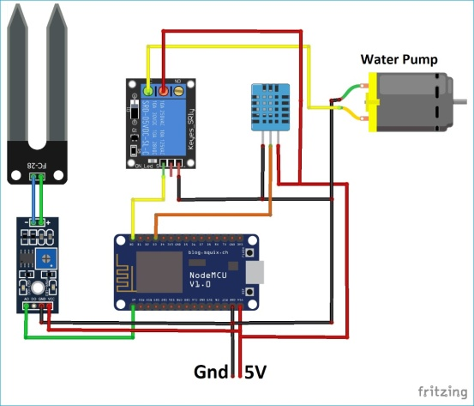The system also integrates a **DHT11 sensor**, which measures the environmental **temperature and humidity**. This sensor sends **digital output** to the NodeMCU. These climate conditions are important not only for irrigation decisions but also for data logging and analysis. Monitoring humidity and temperature helps maintain optimal crop-growing conditions.

Fig.3.1 Proposed system block diagram

Based on the readings from the sensors, the NodeMCU executes a **decision-making algorithm**. If the soil moisture is low, it sends a signal to the **relay module,** which in turn activates the **water pump**. This action waters the crops automatically, without the need for manual intervention. Once the moisture level returns to a healthy range, the NodeMCU turns the pump off. The **relay module** acts as a switch, allowing the low-power NodeMCU to control the higher-power pump safely. When the relay is triggered, it closes the circuit, powering the **DC water pump**, which draws water from a reservoir and irrigates the soil. This mechanism ensures efficient water usage and reduces wastage.

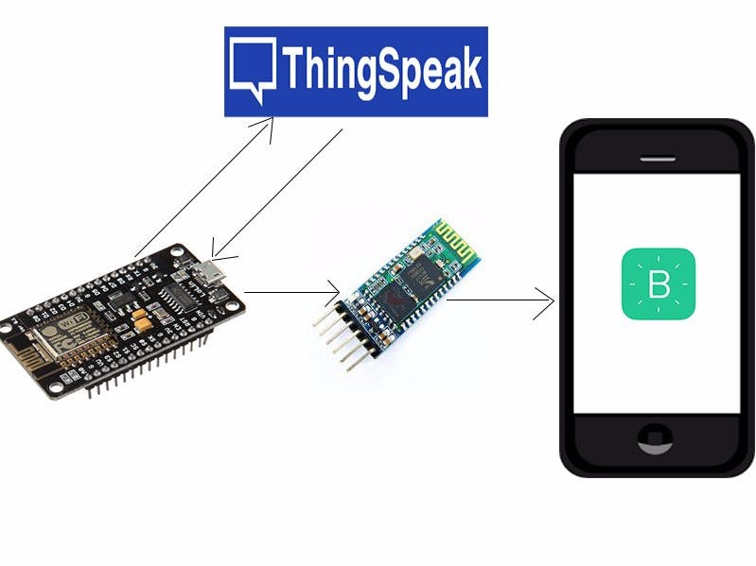An additional benefit of this system is its **real-time monitoring** capability. By uploading data to platforms like **Blynk, ThingSpeak**, or **Firebase**, users can view live updates of temperature, humidity, and soil moisture levels on their smartphones or computers. Alerts and notifications can also be set up for conditions such as dry soil or excessive heat.

Fig.3.1.2 Platforms Used For Mointoring Systems

Lastly, the power supply and grounding are essential for system stability. The entire circuit operates on a **5V power source,** which is sufficient for the NodeMCU, sensors, and the relay. A common ground (GND) is shared among all components to prevent voltage fluctuations and ensure smooth operation. This system can be expanded to include solar power or battery backup for use in remote agricultural areas.

**3.2 ESP8266 WI-FI MODULE SPECIFICATIONS**

* It is a powerful Wi-Fi module available in a compact size .
* It is based on the L106 RISC 32-bit microprocessor , runs at 80 MHz.
* It requires only 3.3 Volts power supply
* The current consumption is 100 m Amps
* The maximum Input/Output (I/O) voltage is 3.6 Volts.
* It consumes 100 mA current
* The maximum Input/Output source current is 12 mA
* The frequency of built-in low power 32-bit MCU is 80 MHz
* The size of flash memory is 513 kb
* It is used as either an access point or station or both
* It supports serial communication to be compatible with several developmental platforms such as Arduino
* It is programmed using either AT commands, Arduino IDE, or Lua script

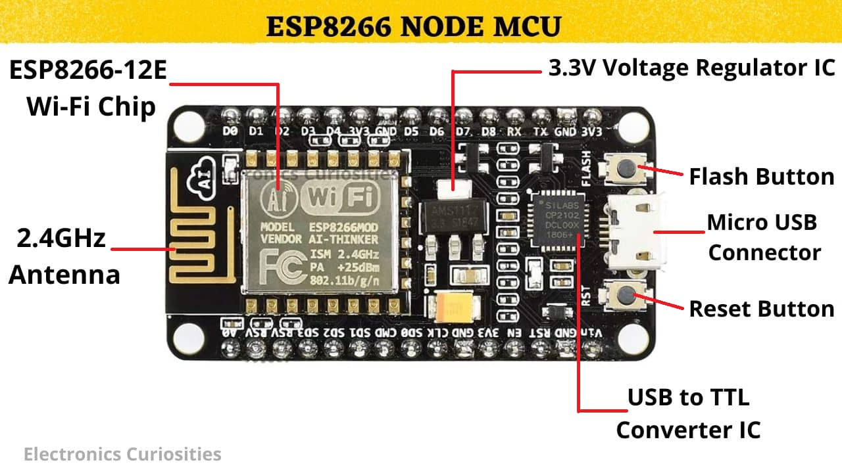

Fig.3.2 ESP8266 NODE MCU

* It uses two serial communication protocols like I2C and SPI
* It provides 10- bit analog to digital conversion
* The type of modulation is PWM (Pulse Width Modulation)
* UART is enabled on dedicated pins and for only transmission,
* GPIO pins – 17
* Memory Size of instruction RAM – 32 KB
* The memory size of instruction cache RAM – 32 KB

**3.3 THINGSPEAK PLATFORM USED IN PROPOSED PROJECT**

ThingSpeak is an efficient and widely used IoT platform for implementing smart irrigation monitoring systems. It enables real-time data collection from various sensors such as soil moisture, temperature, and humidity using devices like ESP32 or Arduino. This allows continuous monitoring of field conditions, ensuring timely and precise irrigation. One of the key advantages of ThingSpeak is its built-in data visualization capabilities, which help users observe trends in environmental conditions. This visualization aids in understanding soil behavior and making better decisions.

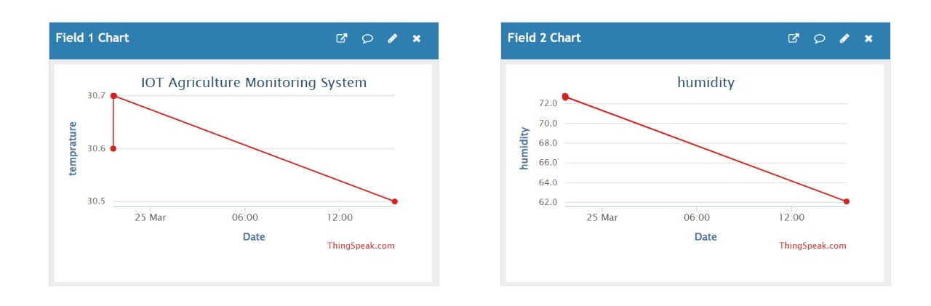Another advantage of ThingSpeak is its ease of integration with common IoT development boards like the ESP8266, ESP32, and Raspberry Pi. This makes the platform highly suitable for low-cost and scalable smart agriculture solutions, especially in rural areas. In summary, ThingSpeak enhances the efficiency of smart irrigation systems by enabling real-time monitoring, intelligent decision-making, and remote control, all while maintaining a user-friendly and cost-effective setup.

**Fig.3.3 Monitoring System in Thingspeak**

The image shows a ThingSpeak dashboard used in an IoT Agriculture Monitoring System to display real-time environmental data. The first chart (Field 1) displays the temperature readings over time. On March 25, the temperature starts at approximately 30.7°C and shows a slight decrease over the day, ending around 30.5°C. This chart helps monitor the thermal conditions of the environment.

4.  **RESULT AND DISCUSSION**

The smart irrigation monitoring system developed using the ESP8266 microcontroller and the ThingSpeak IoT platform demonstrated an effective and efficient method for automating irrigation based on real-time environmental conditions. The ESP8266 was interfaced with soil moisture sensors and DHT11 (or DHT22) sensors to collect data related to soil moisture, temperature, and humidity. This data was transmitted wirelessly to the ThingSpeak cloud platform using Wi-Fi, where it was stored, visualized, and analyzed.

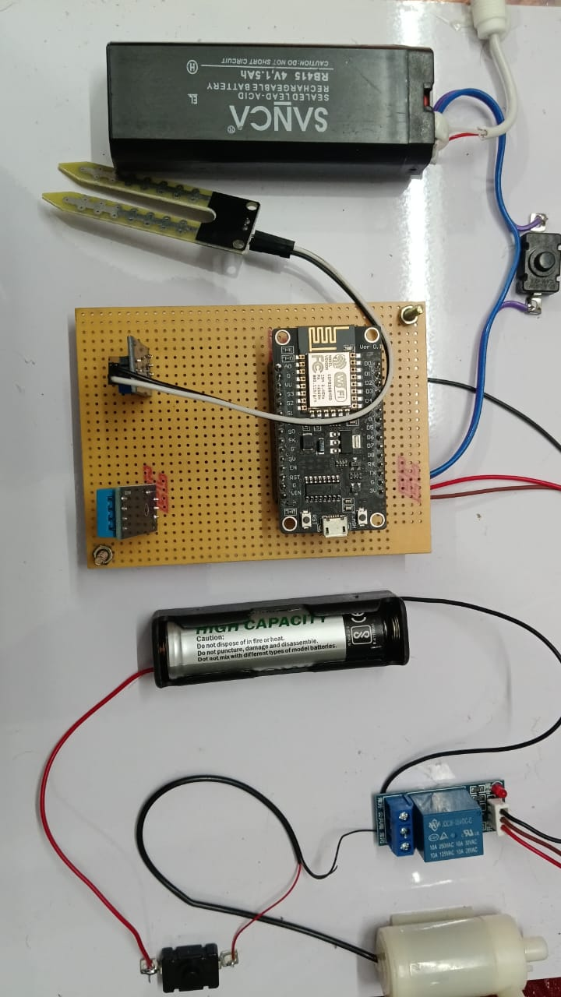During testing, the system successfully uploaded sensor readings to ThingSpeak at regular intervals, and the visual representation of the data helped in identifying patterns in soil moisture levels For instance, when the soil moisture dropped below a predefined threshold, the system automatically triggered a relay to turn on a water pump. Once the moisture level reached an optimal value, the pump was turned off automatically. This not only minimized human intervention but also helped in optimizing water usage.

**Fig.4. Output Of The Proposed System**

The results indicate that the system is reliable and efficient in maintaining soil moisture within a desired range, which is critical for plant health and water conservation. The remote accessibility of the system through the internet allows farmers or users to monitor field conditions from anywhere, making it highly suitable for modern precision agriculture. Overall, the project proved the feasibility and practicality of using IoT and cloud platforms like ThingSpeak for developing low-cost, scalable smart irrigation solutions.

**5. CONCLUSION AND FUTURE SCOPE**

The smart irrigation system designed using ESP8266 and the ThingSpeak platform successfully demonstrates the integration of IoT in modern agriculture. It automates the irrigation process based on real-time environmental and soil data, reducing the need for human intervention. By continuously monitoring parameters like soil moisture, temperature, and humidity, the system ensures that crops receive water only when necessary. This targeted watering approach helps conserve water, which is especially crucial in areas facing water scarcity**.**

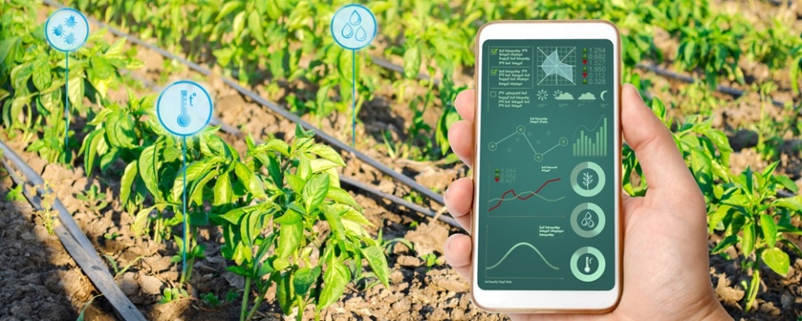

**Fig.5 digitized irrigation**

ThingSpeak serves as a cloud-based data hub, storing sensor values and providing visualizations that are easy to interpret. It also allows remote monitoring and control, enabling farmers or users to keep track of field conditions and operate pumps from anywhere using the internet. During testing, the system responded accurately to changes in soil moisture. When the moisture dropped below the preset threshold, the pump was activated, and it turned off once optimal moisture was reached. This automation supports healthier crop growth and reduces water wastage.

The project proves that low-cost components like ESP8266 and open-source platforms like ThingSpeak can be used to build scalable and practical smart farming solutions. It also lays the groundwork for further research and development in precision agriculture. In the future, mobile apps, SMS alerts, and voice assistant features can enhance user interaction. Additionally, solar power integration could make the system energy-efficient and suitable for deployment in remote or off-grid farming areas, making it a sustainable solution for smart agriculture.

**REFERENCES**

[1] P. Rawal, M. Goyal, A. Shrivastava and D. A. Patel, "IoT based smart irrigation system using soil moisture sensor," 2021 6th International Conference on Inventive Computation Technologies (ICICT), Coimbatore, India, 2021, pp. 1124-1129.

[2] S. R. Nandurkar, V. R. Thool, R. C. Thool, "Design and development of precision agriculture system using wireless sensor network," 2014 IEEE International Conference on Automation, Control, Energy and Systems (ACES), Hooghy, India, 2014, pp. 1-6.

[3] A. Kulkarni and R. Sathe, "Smart irrigation system using IoT and cloud," 2014 IEEE Global Conference on Wireless Computing and Networking (GCWCN), Lonavala, India, 2014, pp. 1-4.

[4] S. Raut, P. Jadhav and A. Chavan, "IoT based Smart Irrigation System for Efficient Water Usage," 2023 International Conference on Smart Systems and Inventive Technology (ICSSIT), Chennai, India, 2023, pp. 356-360.

[5] M. A. Mazidi, S. A. Khandoker, and M. H. Kabir, "Development of a smart irrigation system using IoT," 2020 IEEE Region 10 Symposium (TENSYMP), Dhaka, Bangladesh, 2020, pp. 820–823.

[6] B. R. Pavithra and M. S. Srinath, "GSM based automatic irrigation control system for efficient use of resources and crop planning by using an Android mobile," 2014 IEEE International Conference on Automation, Control, Energy and Systems (ACES), Hooghy, India, 2014, pp. 1–4.

[7] A. P. Chandrasekar and S. Sangeetha, "Automatic irrigation system on sensing soil moisture content," 2010 International Conference on Control, Automation, Communication and Energy Conservation, Perundurai, India, 2010, pp. 1–4.

[8] M. R. Palattella et al., "Internet of Things in the 5G Era: Enablers, Architecture, and Business Models," IEEE Journal on Selected Areas in Communications, vol. 34, no. 3, pp. 510–527, Mar. 2016.

[9] A. V. Raut, P. D. Kulkarni, and V. V. Dixit, "Smart irrigation system using IoT and cloud computing," 2020 4th International Conference on Intelligent Computing and Control Systems (ICICCS), Madurai, India, 2020, pp. 818–823.

[10] M. A. ElGamal, A. M. El-Moursy, and M. A. El-Awady, "A solar powered smart irrigation system using IoT," 2018 International Conference on Innovative Trends in Computer Engineering (ITCE), Aswan, Egypt, 2018, pp. 174–178.